Pay Period Profile Agent Review

Most Critical Issues

- Asking the user to confirm twice, first historical data and then configuration data
- Asking user to confirm the wrong data set wrong data being configured
- Technical jargon throughout
- Doesn't clarify unclear user input or validate illogical combinations
- Ask unnecessary questions during the setup process

Principle | Score
Clarity | 2/5 | Key details missing from the review, plus jargon
Brevity | 1/5 | Long, repeated ML metadata  Ask unnecessary questions to set up new pay schedule
Context Awareness | 1.5/5 | Shows extraction metadata instead of configuration preview; Historical dates not flagged for update; User intent ambiguity not recognized
Consistency | 1.5/5 | Data Contradiction and mixed labels/statuses
Empathy tone | 2/5 | Exposes internal problems which reduces trust and feels unpolished
Error Recovery | 1.5 | No clear “help/clarify” pathways when user intent is unclear; no graceful fallback shown. Not meaningfully tested in this flow
Turn-Taking & Flow | 2/5 | Unnecessary confirmations after successful upload and repetitive, non-progressive confirmations
Confirmation & Feedback | 2/5 | Shows confirmation, but of extraction data instead of configuration preview; system confirmation and bot behavior out of sync
Proactive Guidance | 1.5/5 | Doesn’t flag illogical inputs or explain why that’s risky; no guided disambiguation
Accessibility | 2/5 | Heavy use of technical/ML terms raises reading level and adds cognitive load
Overall average | 1.8/5

Issue: Incomplete information presented for review, user is unclear what was configured
Missing info
Weekend/Holiday Rules, Pay Period start/ end, Pay date, Frequency, Work week start/ end

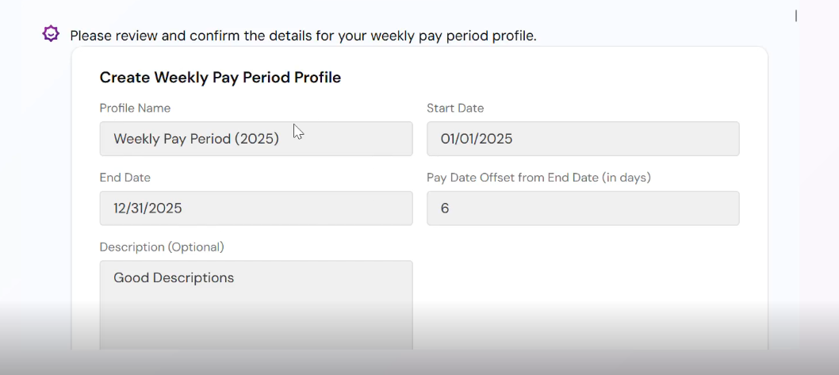

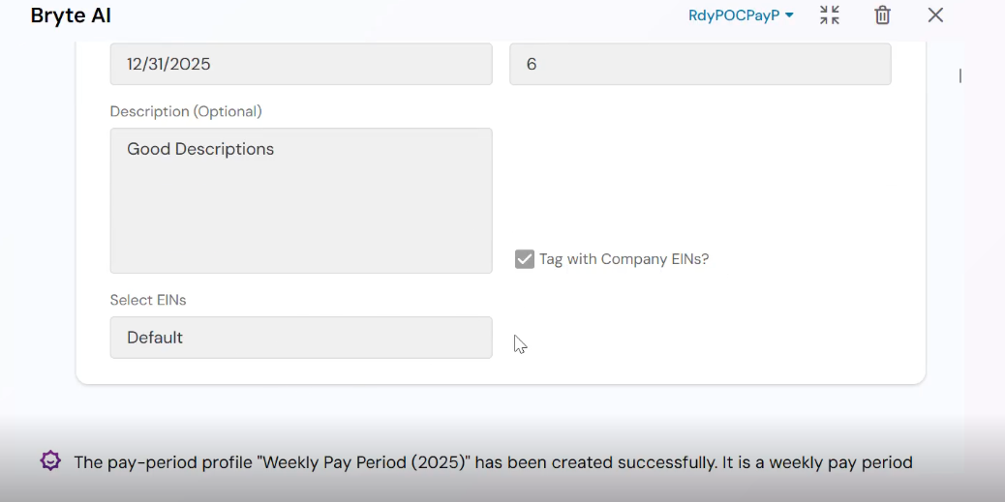
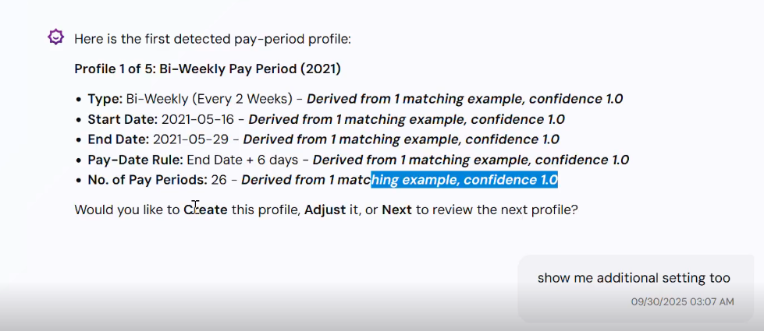

Issue: Technical/UKG system jargon

Pay date offset from end date



Derived from 1 matching example, confidence 1.0 à ML/data extraction term
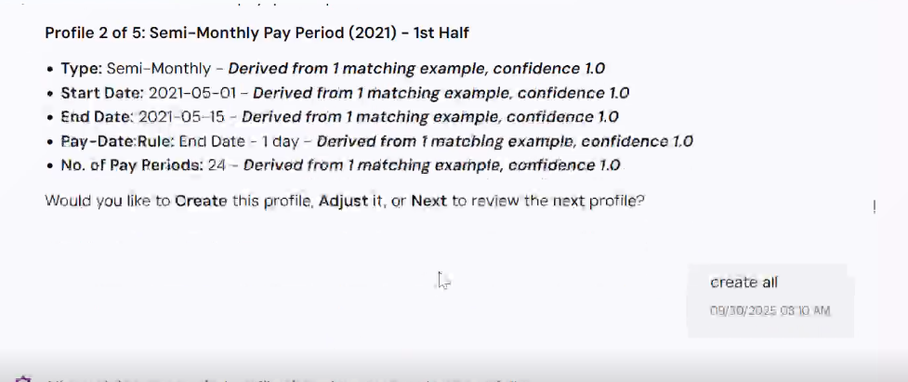
Across 1 example à ML/data extraction term
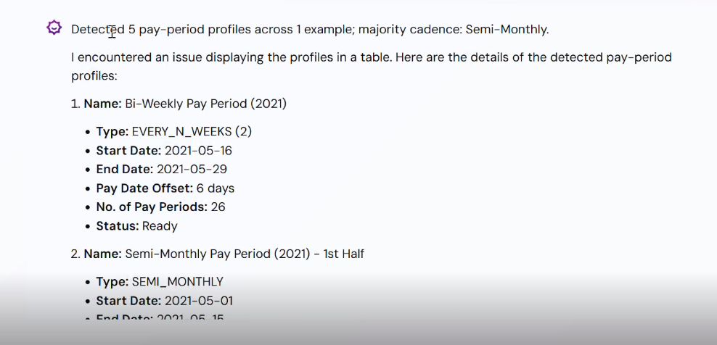

Issue: confusing terminology
“across 1 example"
What does this mean?
1 document? (multiPay.pdf) ? 1 sample row in the PDF? 1 company example?




“Status: ready”
What does status: ready means?
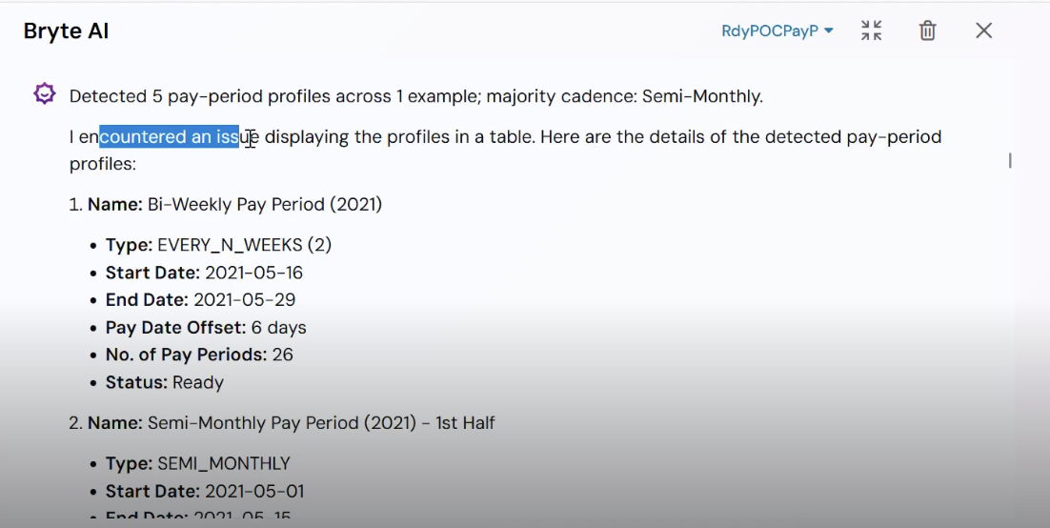

What is “tag with Company EINs”?


Context Awareness

Issue: shows extraction metadata instead of configuration preview
- User needs: Confirmation of what will be configured
- However, AI shows: Raw extraction data from historical pay register
- This is fundamentally wrong context



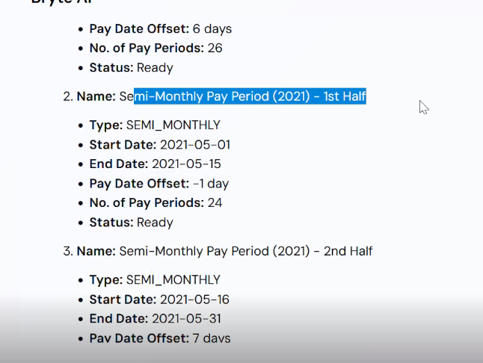

Issue: AI doesn't recognize that user input is unclear

This is unclear because:
- Grammatically broken
- We literally cannot parse what user wants
- Could mean multiple different things
Is this:
- A question? ("Can you setup if..." = asking if it's possible?)
- A request? ("Can you setup..." = asking to do it?)

AI should
- detect: "This message is ambiguous"
- understand: "I need clarification before proceeding"
- adapt: Don’t assume meaning

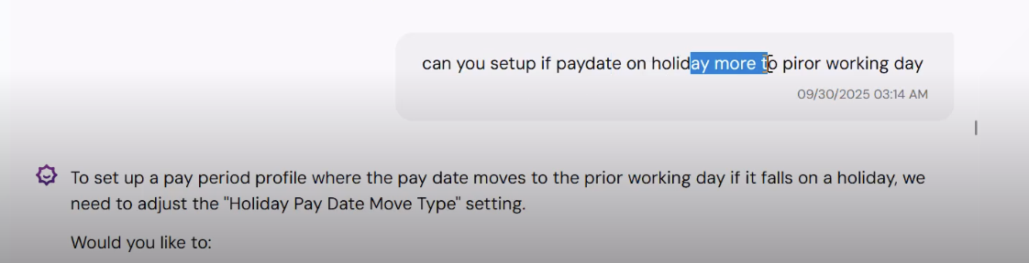

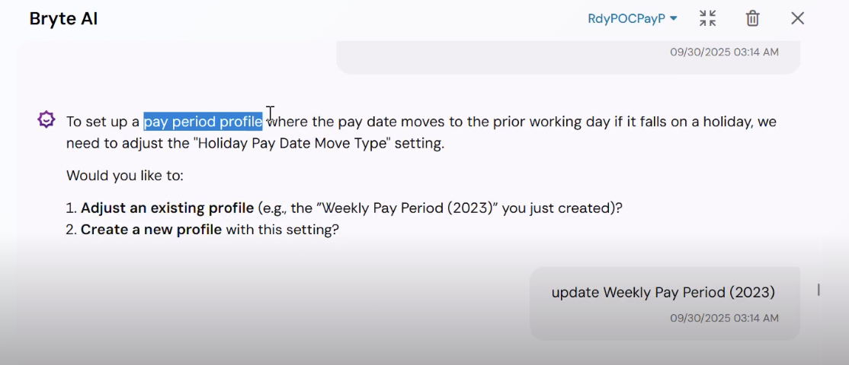

Issue: Treats historical examples as configuration settings

Start and end date is historical data, not what user need to configure
User will be confused
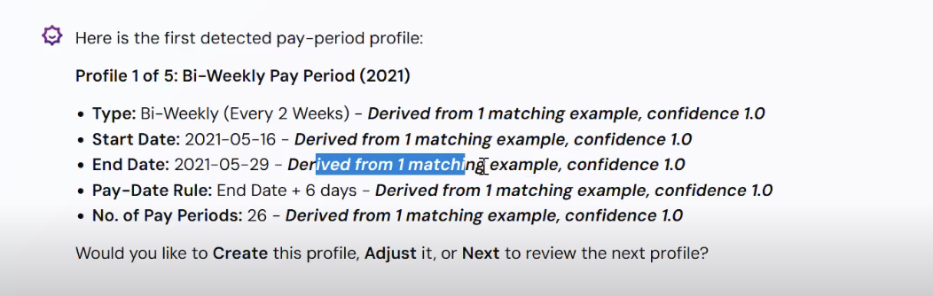

Issue: AI doesn’t recognize user’s intent ambiguity
I want a weekly pay period starting 1 Jan 2025 to 31 dec 2025
- AI doesn't recognize that weekly pay periods + end dates don't make logical sense together
- User's intent is ambiguous (do they understand what a weekly pay period is?)
- AI doesn't clarify the ambiguity before proceeding
- Creates potential for misconfiguration that could affect payroll compliance
- User may not realize they've made a mistake until it's too late
What should happen
- The AI should proactively say: "I notice you mentioned December 31, 2025 as an end date. Weekly pay periods typically run indefinitely—there's no end date unless you're planning to change your pay schedule later. Can you help me understand what you meant?
Current behavior
- AI silently accepts the illogical end date and includes it in the form, allowing user to create an incorrectly configured pay period.
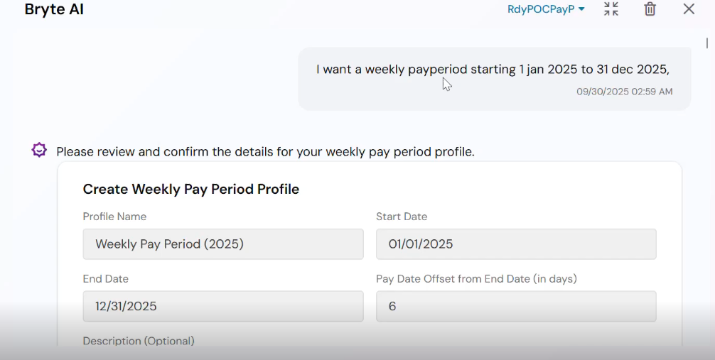

Issue: lacks domain knowledge
I want a weekly pay period starting 1 Jan 2025 to 31 dec 2025
- AI doesn't recognize that weekly pay periods + end dates don't make logical sense together and the contradictions
- Lacks domain knowledge about payroll best practices
- Doesn't detect the mismatch between user input and payroll system requirements
- Per documentation: "If the period remains active indefinitely, leave the To date blank. You only need to fill in the To date if your pay period is changing."
What should happen: AI should recognize this is unusual and use its domain knowledge to guide the user: "Based on standard payroll practices, weekly schedules don't typically have end dates. Here's why..."
Current behavior: Shows no awareness that this input is problematic for a weekly pay period.


Issue: doesn’t know that the file is uploaded
• System literally just said "File uploaded successfully"
• AI asks "Would you like to create from this file?"
• AI should ALREADY KNOW file was uploaded

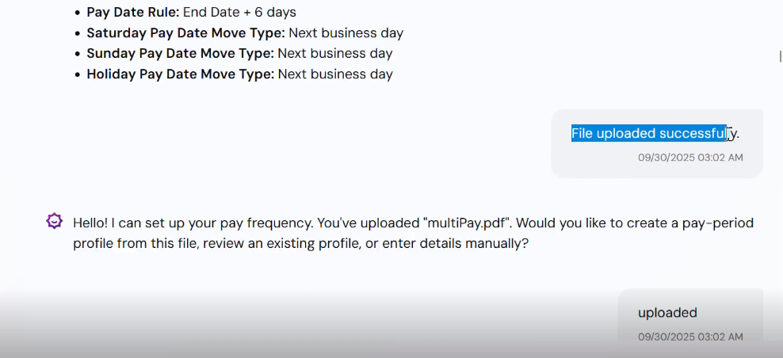

Consistency

Issue: Contradicts itself immediately
"majority cadence: Semi-Monthly"

But Profile #1 shows: "Bi-Weekly Pay Period (2021)" - Type: EVERY_N_WEEKS (2)

User sees: Wait, it says semi-monthly but only 2 out of 5 are semi-monthly
Creates confusion about what was found

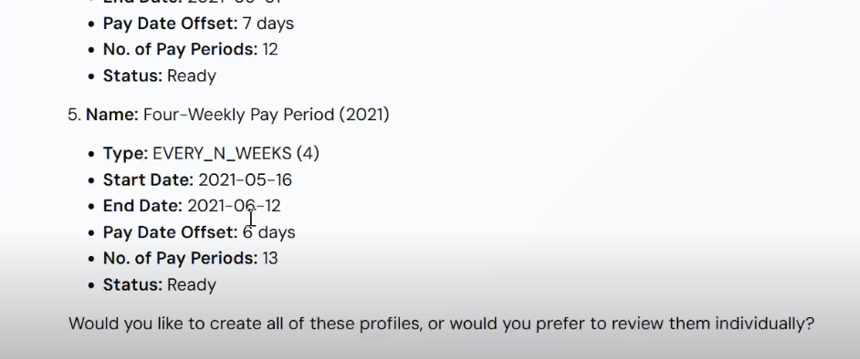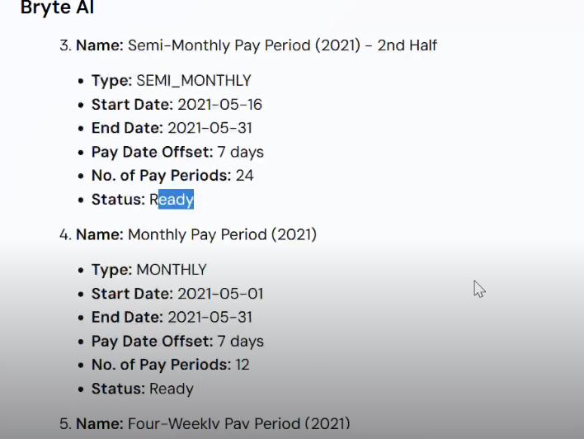
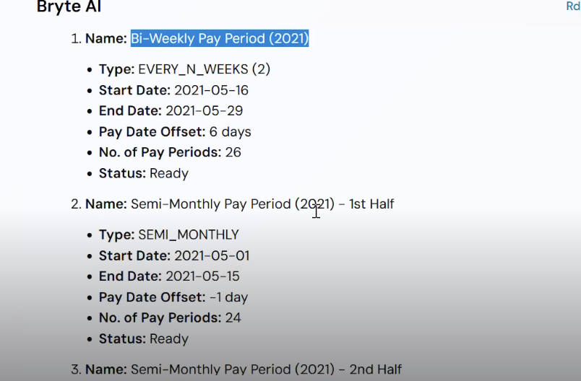

Empathy & tone
Issue: Lack of professional credibility – dimmish trust
I encountered an issue displaying the profiles in a table
User should never know this because:
Why it diminishes trust:
- Exposes internal technical problems to user
- Makes system appear unreliable/unfinished
- User questions: "If it can't show a table, what else might be broken?"
- Creates doubt about system's ability to handle payroll correctly



Turn-taking
Issue: Unnecessary confirmation

The files has been uploaded, why is the AI asking the user the next step? Shouldn’t the AI just display the summary?



Confirmation and feedback
Issue: System confirms but AI acts unaware


